Self assessment


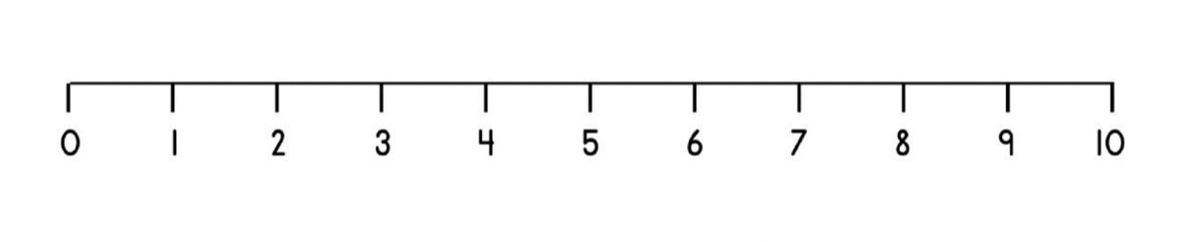
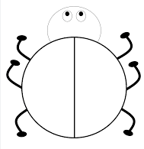

Extension: Make this ladybird show a number bond to 10

______ + ______ = 10

______ + ______ = 10

______ + ______ = 10

______ + ______ = 10

______ + ______ = 10

______ + ______ = 10

______ + ______ = 10

______ + ______ = 10

______ + ______ = 10

______ + ______ = 10

______ + ______ = 10

______ + ______ = 10

______ + ______ = 10

______ + ______ = 10

______ + ______ = 10

______ + ______ = 10

______ + ______ = 10

______ + ______ = 10

______ + ______ = 10

______ + ______ = 10

Highlight the way you worked out the missing numbers.

- In my head

- Number line

- Counters

- Supported by an adult

